**OVERVIEW**

“Food catcher” is a basic 2D arcade game where the player(chef) and get as many foods.

The Game’s premise: the game consists of a chef which appears near the bottom of the gameplay

screen with a background image of a restaurant close to the Eiffel tower. The user can move the

chef to the left and right using the corresponding arrow keys. A series of food fall from the top of the

screen.

Each food will fall from a different x position, with different speeds between 3 and 8 pixels per frame

straight down.

If a food or leaves the bottom of the screen, it is reset to a new random position at the

top of the Screen with a new falling speed.

**THE GAME CLASS**

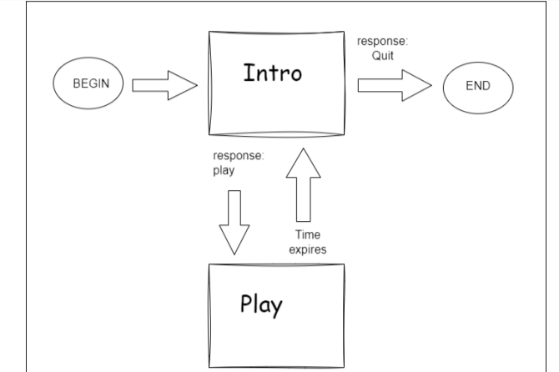

**Algorithm**

Import pygame, simpleGE and random

Create a class named game

Define __init__

Set the background to a highway

Create the cooking sound

Create a sprite called chef

Create a sprite list

Define process

Check if any of the food collide with the chef

If they do

Play the foodprep sound and reset the food

Subtract 5 points after collision

Check if any of the coins collide with the racer

If they do

Play the foodprep sound and reset the food

Add 20 points after collision

Check if time left is < 0

If time left is < 0

Print the score(the points)

Stop game

Check if the chef is still on the food

If it is off the highway, continue

Create a class named chef

Define __init__

Set the chef image to be a chef

Define the size, movement speed, position and angle

Define process

If the left arrow is pressed, move the car left by its movement speed

If the right arrow is pressed, move the car right by its movement speed

Create a class named food

Define __init__

Set the food image to be a chef

Define the size, max and min movement speeds, and angle

Give them their starting positions

Set dy equal to a random number between the max and min speed

Define reset

Reset the food up to the top of the screen with a random x location on the road

Give it a random movement speed between its max and min speeds

Define checkbounds

Check if the obstacle is at the bottom of the screen and if it is, reset it

Create a class named kichen

Define __init__

Set the image to be a kitchen

Define the size to be screen size

Define checkbounds

Check if the coin is at the bottom of the screen and if it is, reset it

Define main function

Run the game

Start the game